**GOOGLE AND WHOIS FOR RECONNAISANCE**

**Ex No :04**

**Date:08-05-2023**

**Aim :**

To use WHO.IS website to find details of a domain.

**Procedure :**

* Open google.
* Then go to website who.is
* The give a domain name in search bar.
* It provides all the datails of that Doamin.
* It includes ( whois DNSRecords and Diagnostics ).

**Output :**

Open who.is website

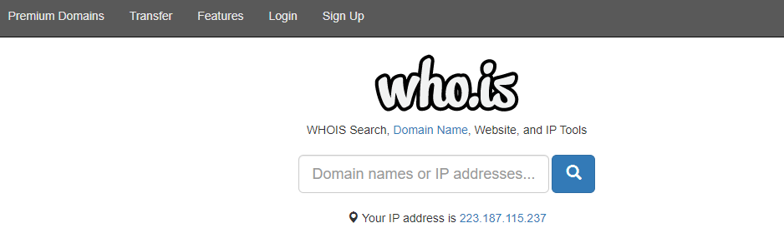

Enter the name of domain

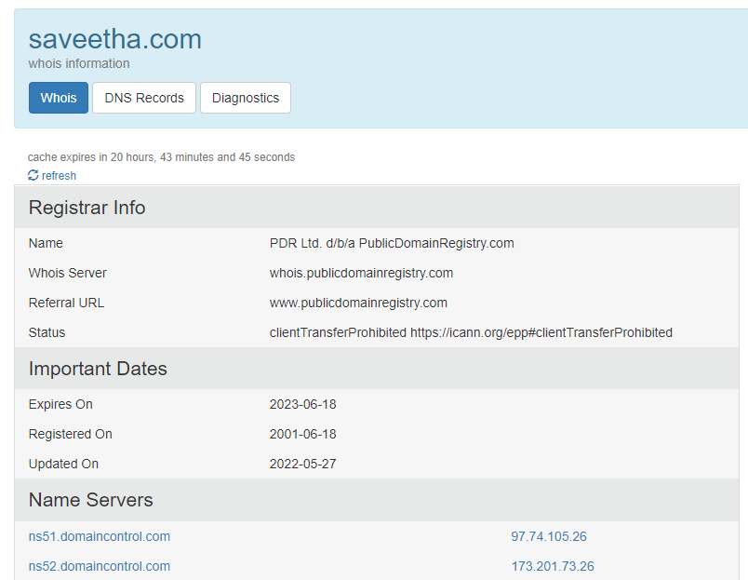

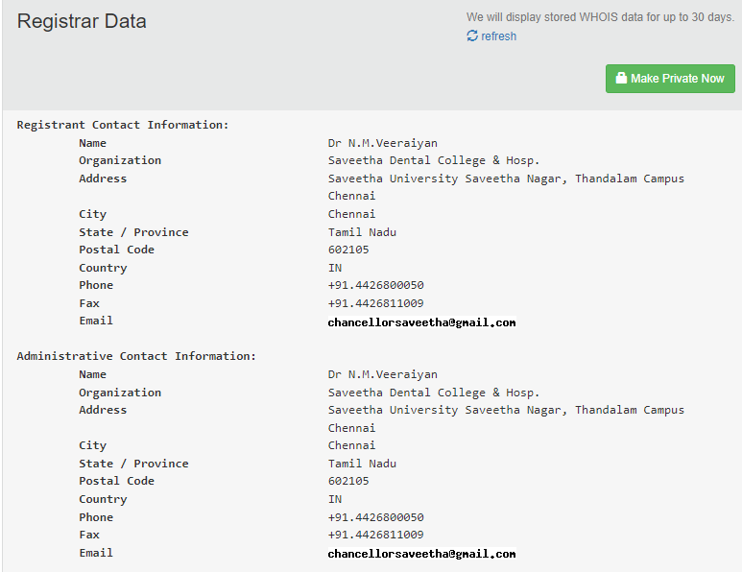

Dns records

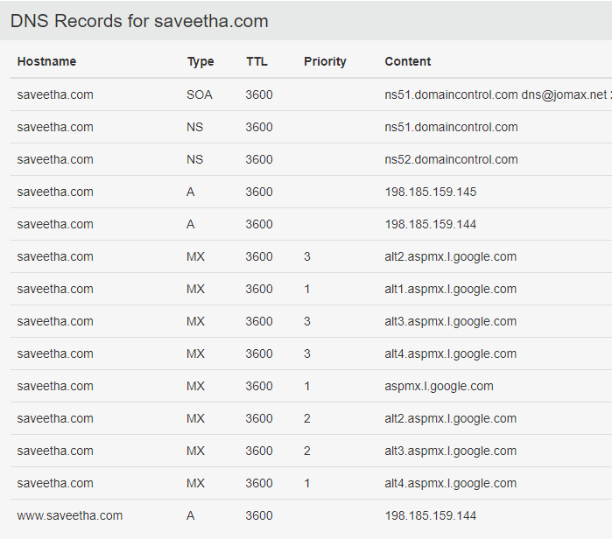

Diagnostics

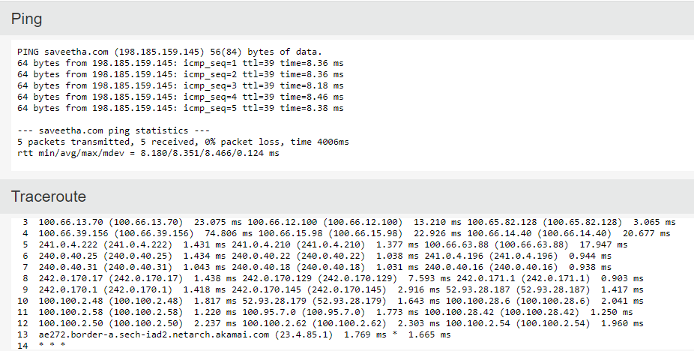

**Result :**

Hence the details of a Domain using who.is is Found in Google.